Predicting Disney Stock Price Research Questions/Answers

David Berberena

Bellevue University

DSC 680 Applied Data Science

Amirfarrokh Iranitalab

October 20, 2024

Predicting Disney Stock Price Research Questions/Answers

Questions that I believe end users would be interested in knowing about the prediction of Disney’s stock price are vast, but there are a few key ideas that come to mind that the general public may inquire as to how this study will yield viable future results:

1. How can you confidently predict Disney’s stock price?

**ANSWER:** Using predictive modeling techniques available within the data science industry, data that outlines Disney’s stock prices over several decades has been analyzed for underlying trends and patterns, placed into a predictive machine learning algorithm, and viable stock price predictions have been realized and compared to actual stock prices to view the margin of error between both sets of observations. As the Walt Disney Company stock price data over time is considered time series data, the methodology in which the data was handled addressed the behavior of the stock price over time, and predictive models that lend itself to working with this type of data were employed with varying results, yet were successful at the end of the study in producing accurate real-world predictions of the Company’s closing stock price, the outcome variable this research was based on.

1. Will a recommendation be provided once future stock prices are predicted, such as the Walt Disney Company being a Strong Buy, Hold, or Sell stock?

**ANSWER:** This study is focused on predicting the Walt Disney Company’s closing stock price after analyzing the Company’s historical stock price data. There are nor will there be any financial evaluations of the Company’s performance on the stock market that recommend the stock as a Strong Buy, Hold, or Sell as that is irrelevant to the goal of the research at hand.

1. What external factors will be taken under consideration that are not within the data for the stock price prediction?

**ANSWER:** Since no external factors have been gathered, none will be analyzed in conjunction with the stock price data that has already been obtained. This inclusion of exogenous variables, like Company layoffs, acts of God in the form of hurricanes, the COVID-19 pandemic, CEO changes, and other impactful Company changes as outlined in news press releases and official Company conventions such as D23, is noted as an opportunity to explore future predictions provided the current research needs more fine-tuning.

1. Is this research illegal, as it should be considered insider information?

**ANSWER:** This research is perfectly legal as all the information used within the study is public information regarding the Walt Disney Company’s historical stock price data. Any features that have been engineered into the original dataset have mathematical origins from those incumbent variables, meaning that no inside information has been divulged and no exterior influence has been exhibited.

1. How do I know the Walt Disney Company is a safe stock to invest in with my money?

**ANSWER:** The word ‘safe’ in terms of the stock market is relative to the risk an investor is willing to take to gain or lose capital potentially. Regarding the Walt Disney Company, analyzing the historical stock price data has shown that the Company’s stock has flourished over the last sixty years, and has proved a lucrative investment for many individuals. While it is true that the stock market is very fickle and prices fluctuate almost endlessly, the trend realized after looking over the stock price data is that Disney’s stock has significantly increased from its closing price 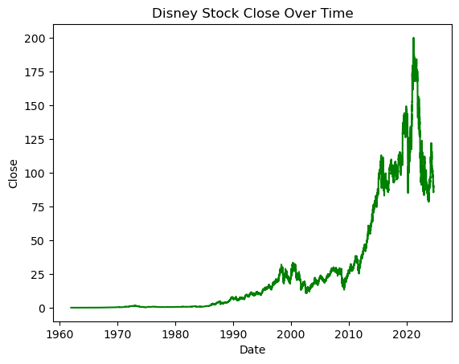back in 1962 to the final year listed in the data (2024). This is evident in the below chart.

While this study cannot provide definitive orders concerning how a potential shareholder may invest their money, the research provides many insights that spur data-driven decisions. It is up to the consumers themselves to make the distinction based on the amount of risk they are willing to take whether the Walt Disney Company is a safe investment for them to undertake.

1. What stock price within the data are you using to base predicted stock prices since the data has four price categories to choose from?

**ANSWER:** As the question states, indeed there are four stock price variables present within the data: opening stock price, high price, low price, and closing price. I have chosen to use the closing stock price as the dependent variable since almost every current and potential investor has the opportunity to influence the stock price throughout the entirety of the trading day, with the vast majority of trades ending at the stock market close. The closing stock market price can be affected by after-hours trading in the same way the opening stock price is affected by pre-open trading, yet the closing price has less time to be significantly impacted. The closing price also measures a stock’s overall stability, which is another factor has been analyzed and has solidified the closing price as the outcome variable necessary for the accurate prediction of Disney stock price.

1. Can you use the model from this study to show future stock prices so I can buy/sell Disney shares depending on the results?

**ANSWER:** Yes, the random forest regressor model from the study has been used to output future stock prices on unseen data points with these new predictions being compared with actual future values to see the accuracy of the model’s predictions. Should a potential investor wish to base their financial decisions on purely educational research, that is their choice, yet it is not the study’s goal to tell any potential Disney shareholder whether to buy or sell shares of the Company.

1. Does the volume of shares traded impact the stock price?

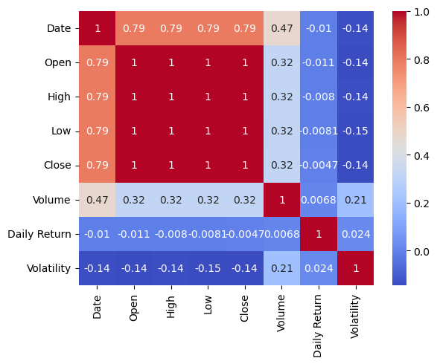**ANSWER:** While the research outlined does not have the Volume variable viewed as impactful to Disney’s closing stock price or significant in predicting the stock price, the study does shed light on how the variables are correlated. The heatmap featured below shows the correlation of each variable to one another, and the Volume variable’s correlation coefficients relating to the other variables can be seen.

The correlation coefficients outlined are a statistical measure of two variable’s strength and direction relative to their relationship. Intriguingly enough, the correlation coefficients for the relationships between Volume and Open, Volume and High, Volume and Low, and Volume and Close are all the same, designated as 0.32. With the correlation coefficient scale here being from -1 to 1, a value of 0.32 suggests a weak positive relationship, meaning that when Volume increases, all of the stock prices steadily increase and when Volume decreases, the stock prices may perform in the same way. Since correlation does not equal causation though, it is untrue to say that the fluctuation of shares traded directly causes the same direction fluctuation of the stock price.

1. What trends appear in Disney’s stock price from the 1960s to now in 2024?

**ANSWER:** Through the creation and analysis of multiple charts of the data, here are a few of the trends that the Walt Disney Company’s stock price has exhibited from the early 1960s to the current year of 2024:

* Disney stock has remained at a constant price from the beginning date of the dataset (January 1, 1962) to around the mid-1980s, then steadily increases until the 2010s where the stock takes off until it reaches an all-time high in the early 2020s with a significant drop following the spike
* The Walt Disney Company’s stock has had several significant spikes in the volume of shares traded, the highest of which was realized in the mid-1980s.
* The date on which Disney stock is traded is highly positively correlated with the stock price at any given time of day (open, close, high, and low) while the stock’s daily return and volatility are almost unrelated.

1. Will the Company be profitable in the coming week? Month? Year?

**ANSWER:** Unfortunately, this is one of the most difficult questions to answer since it is improbable to determine a potential or current investor’s definition of ‘profitable’ when predicting Disney’s stock price. Profitability could refer to the closing stock price growing higher than its previous trading days, which may or may not happen regardless of the predictive methodology demonstrated by the study. Profitability could also mean whether the money a current shareholder would receive upon selling their Disney stock would increase, in which case the predictive modeling the research shares would have some relevance as it could drive the shareholder to make an informed decision based on a real-world version of the models showcased within the study. A final measure of profitability would be the Company’s ability to generate a higher bottom line for each quarter of the fiscal year. While this is potentially one of the most accurate definitions of profitability for the Walt Disney Company, the stock price does not play a large role in that bottom line provided multiple other factors. In terms of weeks, months, or years, the stock price is simply a valuation of a company’s market value and is only considered profitable to the investor/shareholder at these times when they are looking to sell or hold for dividend payments. The study’s techniques and results may help shareholders realize a profit of their own, yet the Company’s financial standing banks on much more than predictive analytics.